Practical 7(1)
class Studentcopy
{
String name;
int age;
Studentcopy (String name,int age)
{
this.name=name;
this.age=age;
}
Studentcopy (Studentcopy s)
{
this.name=s.name;
this.age=s.age;
}
void display()
{
System.out.println("Name:"+this.name);
System.out.println("Age:"+this.age);
}
public static void main(String args[])
{
Studentcopy s=new Studentcopy("Abc",15);
System.out.println("Display the original object");
s.display();
System.out.println("Display the copied object");
Studentcopy copiedstudent=new Studentcopy(s);
copiedstudent.display();
}
}
Output :
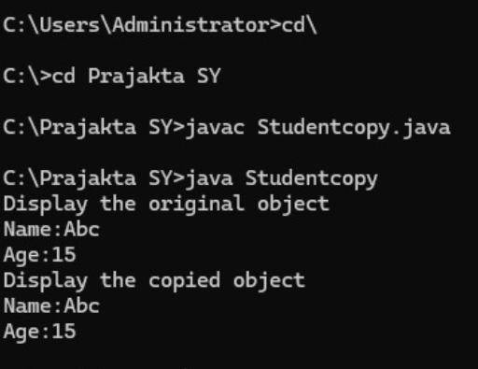

Practical 7(2)
class Java
{
Java()
{
System.out.println("Java is simple language");
}
public static void main (String args[])
{
Java obj= new Java();
}
}
Output :
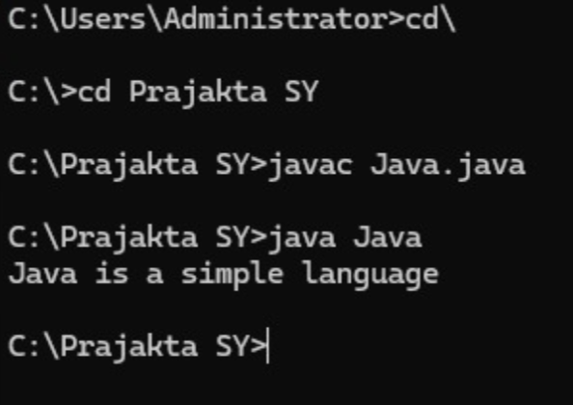

Practical 7(3)
class Student
{
int id;
String name;
Student(int i,String n)
{
id=i;
name=n;
}
void display()
{
System.out.println(id+" "+name);
}
public static void main(String args[])
{
Student s1=new Student(111,"Prajakta");
Student s2=new Student(222,"Tanishka");
s1.display();
s2.display();
}
}
Output :
